HF-SmartLink V8
User Manual
（Android、IOS Platform）

Note：
1、SmartLink is used for fast config module connecting to router. The latest version is V8, it compatible with old version SmartLink V3 and V7.
2、Currently it support the following module. HF-LPX30 and HF-LPX20 series is the most recommended.
3、New release dual band HF-LPD100, support 5G Config.

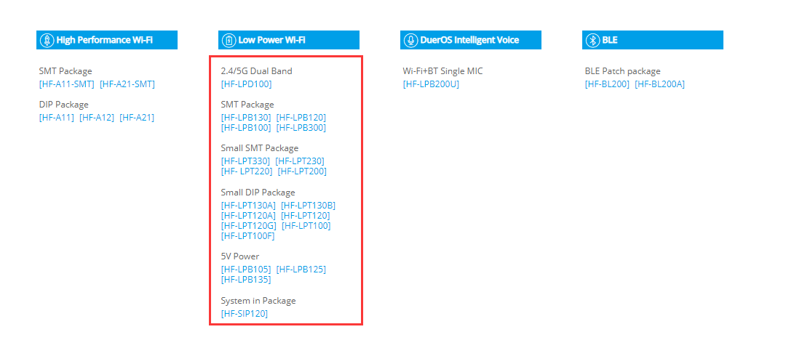

- After installed , there is an icon on the desktop of the OS as following picture.

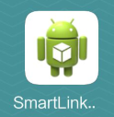
- The smart phone's Wi-Fi connect to router AP(Must choose 2.4G Wi-Fi frequency due to module is 2.4G, HF-LPD100 support 5G, APP need version 8.2)and click the icon to start the program. Click the following Customized Activity to enter the setting interface.

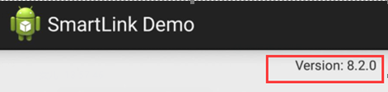

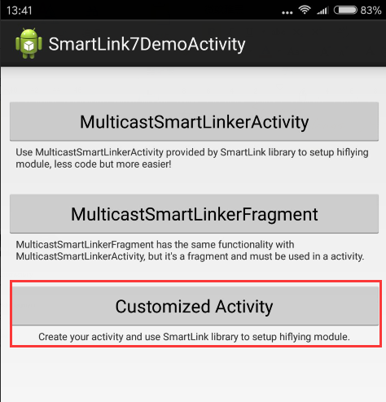
- The setting interface is following
  - SSID：The SSID of router which Smart Terminal is connecting to. It can not be modified.
  - Password：The password of router. Keep blank if the AP has no password.
  - Others: User data, must use module SDK to get this user data, by default is should be blank.
  - Mixed：Sniffer protocol mixed. For HF-LPD100, HF-LPX30 Series(4.11.04 or above version, other lower version should choose V3, please choose Smartlink V8, for HF-LPX20 and HF-LPX00 series, please choose Smartlink V3). The detailed description is as following.

Smartlink V3: UDP broadcast protocol config. This protocol resolution effencify is not very good.

Smartlink V7: UDP multicast protocol config. by detault.

Smartlink V8: UDP broadcast protocol config. This version fixed the V3 effencify problem. The HF-LPX30 4.11.04 version support this protocol.

V3 and V8 are conflict. So the config protocol can be chosen both the V7+V3 or the V7+V8.

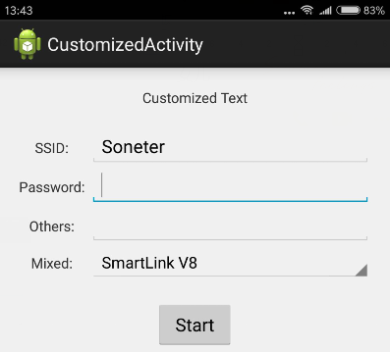

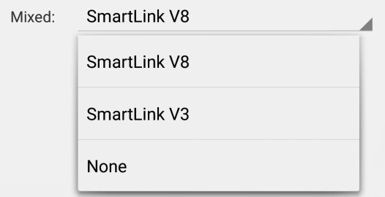
- After the Wi-Fi module is powered up, click the ‘nReload’ button(See reference schemetic) to start SmartLink config mode. The module will reboot and the ‘nLink‘ LED is flashing fast indicating the module is in SmartLink config mode.
- Input the router password and Click the APP “start” button, it will push message to Wi-Fi module, and the APP indicate it is configing the module.

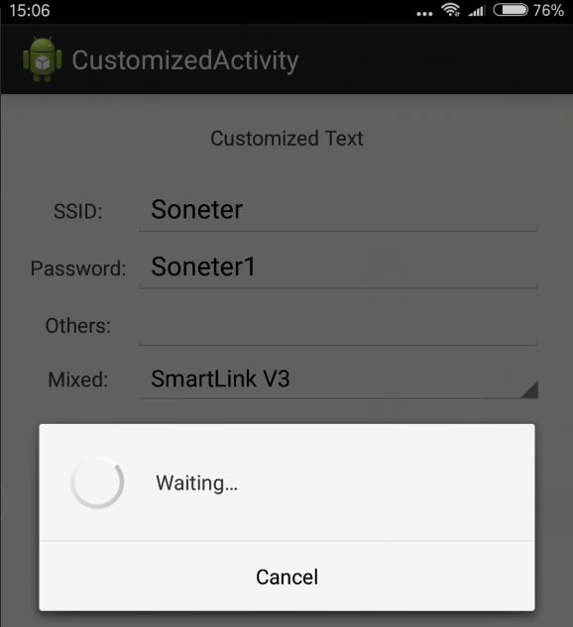

- After the configure process is finished, the Wi-Fi module restart itself and connect to the router in STA mode.
  - “nLink” LED is on indicating the the Wi-Fi module connect to router successfully and the APP shows configure is OK.
  - If the password is error . The “nLink” LED is flashing slowly indicating the configure is failed. Reset the module and configure again.
  - The whole process will continue for 60 seconds， it can config several device. Once configuration is OK， it show "smartlink completed" finnally, otherwise it show "Time Out”.

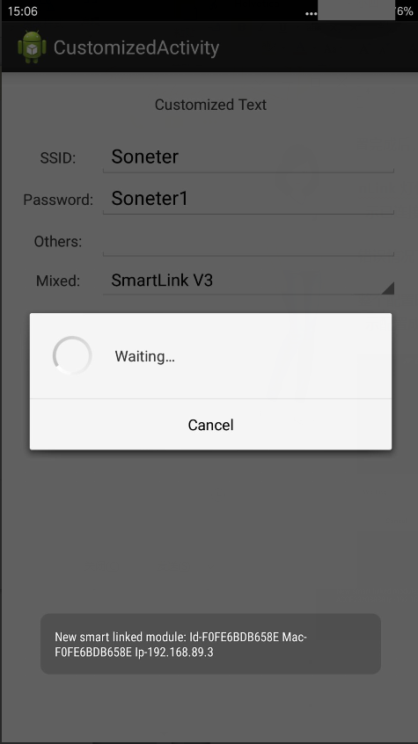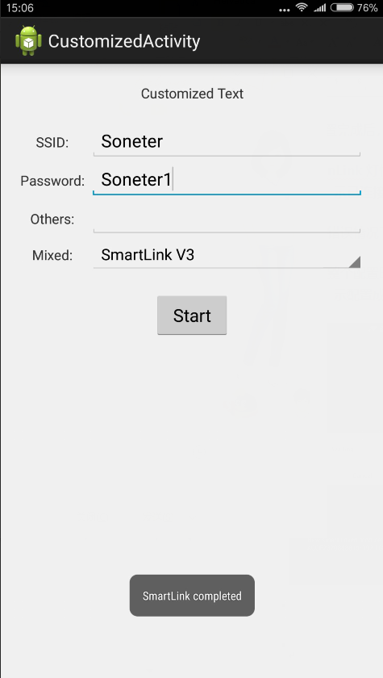

Note：
- For IOS device, download our Smartlink from APPStore.

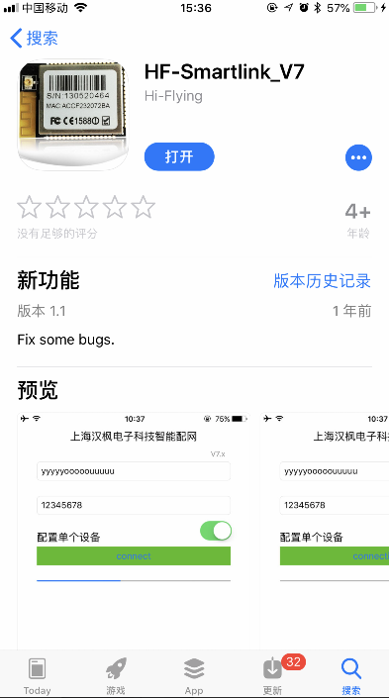
- The First line is router SSID. The second line is router password, the third line is user data.

SmartLink V3 support: If disable it, it use V7+V8. Select corresponding protocol according to the module type.



SmartLink V3 support：If selected, use V7+V3.

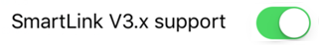

Single Device Configure： once it is on, the APP will stop and show the result if one device is configured successfully, otherwise it will continue for 30 seconds. The other operation is the same as Android APP.

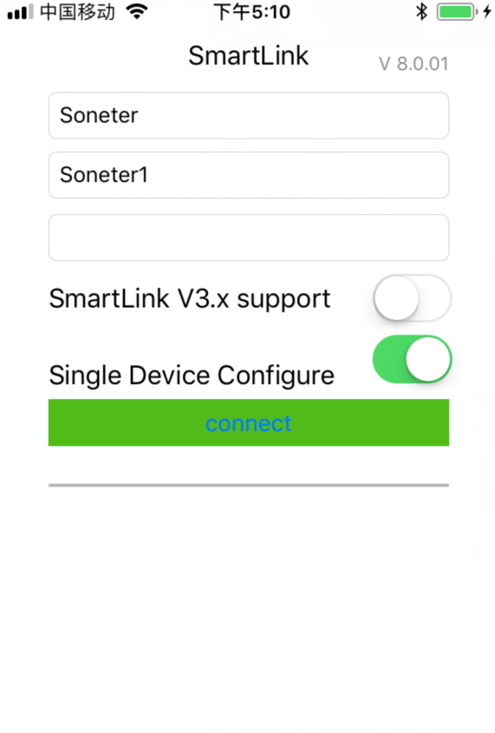
APPENDIX：
1、Hardware connection of Wi-Fi module.
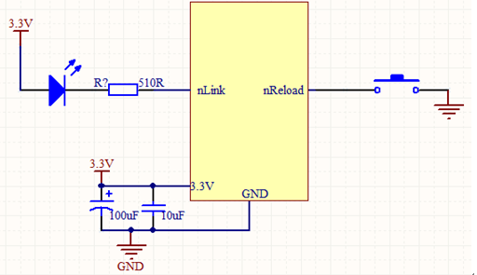
- nReload：SmartLink Function Key.
- nLink：SmartLink Status Indicator.

